**4.2** Sentences 1 and 4 are tautologies.

**4.3**

1. If sentence A is a logical truth (ie, it is true in all logically possible circumstances), then sentence 2 also becomes a logical truth. The rows in which A is false are not logically possible. Sentence 3 is still not a tautology: there is a circumstance in which A is true but the complex sentence is false.
2. On the other hand, if sentence A is logically false, then sentence 3 becomes a logical truth: the complex sentence is true for all logically possible combinations of the constituent atomic sentences. Sentence 2 is now always false for logically possible circumstances, so it is logically false.

**4.4**

B ∧ ¬C ∧ ¬B is always false because B ∧ ¬B is always false in a truth-table sense.

¬(B ∧ ¬C ∧ ¬B) is thus always true and thus a tautology (thus a logical truth).

**4.5**

Not a tautology. TT-possible.

**4.6**

Not a tautology. All entries are false: logically false. Not TT-possible.

**4.7**

Not a tautology. TT-possible.

**4.8**

**Tautologies**

Larger(a,b) ∨ ¬Larger(a,b)

¬(Small(a)∧Small(b))∨Small(a)

**Logical Necessities**

(a=b) | (b=b)

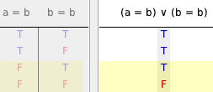

**Tarski’s World Necessities**

¬(Large(a) ∧ Large(b) ∧ Adjoins(a,b))

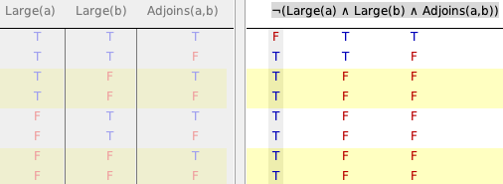

Though it is logically possible for all three atomic sentences to be true, it is not possible in Tarski’s world. If both a and b are large, they can’t be on adjacent squares. Therefore, since the complex sentence is true for all other combinations (ie, all the ones that are Tarski-possible), it is a Tarski-world necessity: it is true in all circumstances that are possible in Tarski’s world.

¬Tet(a)∨ ¬Cube(b)∨(a ≠ b)

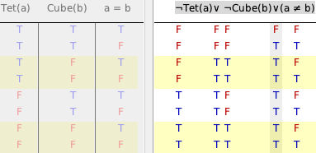

In Tarski’s world, it is not possible for an object to be both a cube and a tetrahedron. Therefore, Tet(a) and Cube(b) cannot both be true if a=b. Since the complex sentence is true in all other combinations, this sentence is Tarski necessary.

SameSize(a,b) ∨ ¬(Small(a)∧Small(b))

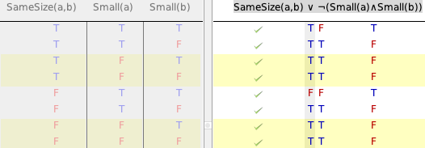

The only circumstance in which the complex sentence is false involves a combination of atomic sentences that is not possible in Tarski’s world: a and b can’t both be small with SameSize(a,b) false.

**General**

a=b

(a=b) & (b=b)

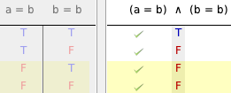

Larger(a,b) ∨ Smaller(a,b)

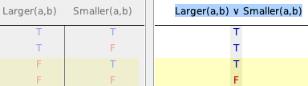

¬(SameCol(a,b)∧SameRow(a,b))

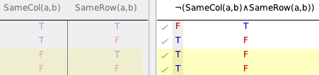

**4.9**

| **Sentence** | **TT-possible** | **TW-possible** |
| --- | --- | --- |
| **1** | **Yes** | **Yes** |
| **2** | **No** | **No** |
| **3** | **Yes** | **No** |
| **4** | **Yes** | **No** |
| **5** | **Yes** | **Yes** |
| **6** | **Yes** | **No** |
| **7** | **Yes** | **No** |
| **8** | **No** | **No** |
| **9** | **Yes** | **Yes** |
| **10** | **Yes** | **Yes** |

If a sentence is TW possible then it is TT possible. In a truth table, every row that represents the complex sentence being true is a TT possible circumstance. Any row that is TW possible must be one of these rows. Therefore, if a row is TW possible it is also TT possible.

**4.10**

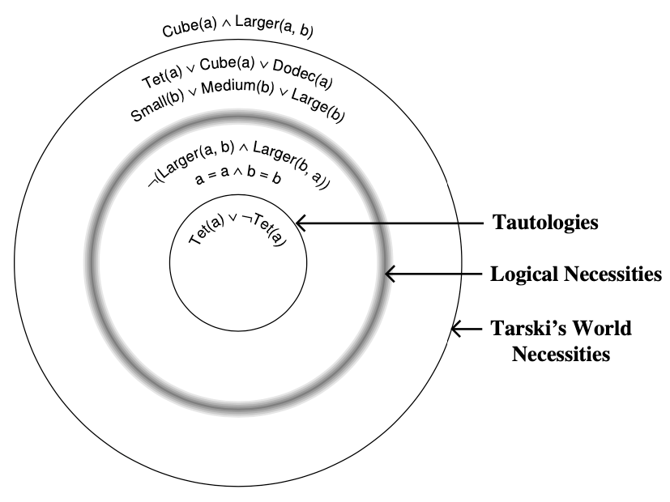

In the above diagram, we can observe a few things

* something that is logically necessary must be true in any world that follows certain logic axioms
* there are things that are necessary in specific worlds that are not necessary in all worlds; this has to do with constraints in those worlds, such as physical constraints in the real world, or the rules of Tarski’s world.
* tautologies are simply sentences that have a certain characteristic; they are a special case of logical necessities

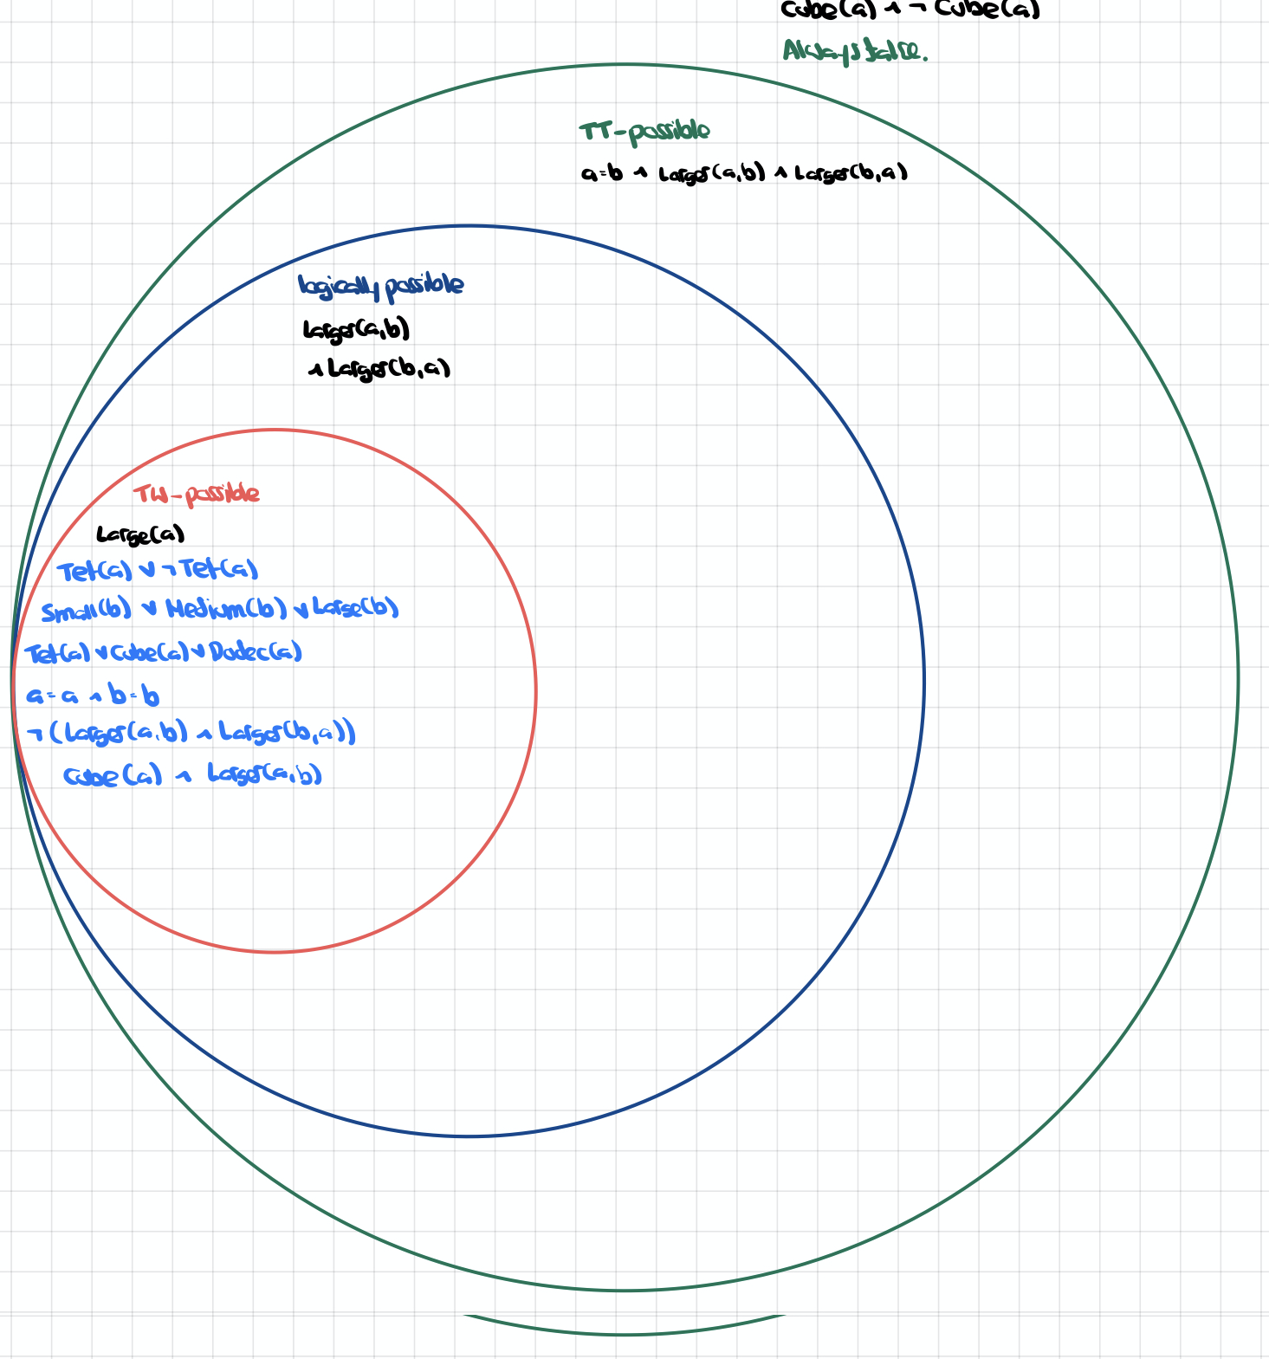

In the diagram above, we can observe the following

* any sentence that is possible in Tarski’s world is logically possible and is also truth table possible.
* in diagram 1, all the statements contained inside of the Tarski necessary circle were possible in Tarski’s world.
* there exist statements that represent impossible circumstances in Tarski’s world, even though they are logically possible.

**4.11**

When we construct a truth table, the reference columns represent sentences that may be atomic or complex. The important thing is that the reference values represent all possible combinations of truth values of the reference columns. It doesn’t matter, in a truth-table sense, what the actual sentence is; the truth table determines the truth values of the resultant complex sentence considering the connectives and their meaning, but nothing else. If we swap out one sentence for another, it doesn’t alter the structure of the connectives nor their meanings. A complex sentence that is a tautology is as much because of its structure (how it connects individual sentences with connectives), independent of what its individual constituent sentences actually are.

**4.12**

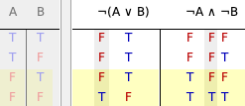

The two sentences are tautologically equivalent because the truth values of the main connectives are exactly the same. They are logically equivalent because whenever one is true, the other is too.

**4.19**

We introduce the notion of TW-equivalence: two sentences are TW-equivalent if and only if they have the same truth value in every world that can be constructed in Tarski’s world.

1) Tautological equivalence is a stricter form of logical equivalence, which is a stricter form of TW-equivalence. If two sentences are TW-equivalent, they have the same truth values in a subset of all logically possible circumstances, namely, the world’s that can exist in Tarski’s world. Any two sentences that are tautologically equivalent have the same truth values in any circumstance, including the ones that are impossible in Tarski’s world and the ones involving logically impossible circumstances. So they are both logically equivalent and TW-equivalent. Any two sentences that are logically equivalent have the same truth values in circumstance that is possible given logical axioms. This includes all the circumstances that are possible within Tarski’s world, so these sentences are also TW-equivalent. Some of these pairs are also tautologically equivalent, but not always, because it can be the case that for certain combinations in the truth table (the ones that are logically impossible), the two sentences do not have the same truth values.

2) The sentences

SameCol(a, b) ∧ SameRow(a, b)

a=b

Are not logically equivalent: their truth tables are quite different.

However, in Tarski’s world, the only way a=b is if a and b have the same row and column, ie if all three predicates are true.

For this particular circumstance, the two original sentences share the same truth value. In every world that can be constructed in Tarski’s world, the two sentences always share the same truth value: if all predicates are true, both sentences are true; if all predicates are false, both sentences are false.

**4.20**

The conclusion is a tautological (and hence logical) consequence of the premise: there are five combinations of atomic sentences that make the premise true, and the conclusion is true for all five of these cases.

**4.21**

The conclusion is not a logical consequence of the premises.

Also note that one of the two cases in which the premises are both true is not logically possible as it involves claire and max each being taller than the other.

**4.22**

The conclusion is a tautological (hence logical) consequence of the premises.

**4.23**

Conclusion is not a logical consequence of the premises.

**4.25**

**Larger(a,b) ∨ Smaller(b,a)**

**Larger(a,b) ∧ Smaller(b,a)**

There are three circumstances in which the premise is true. Two of them, however, are logically impossible because they involve a being larger than b and b not being smaller than a, or vice versa. For logically possible circumstances, every time the premise is true, the conclusion is true. Hence the conclusion is a logical consequence of the premise.